**POWER BI**

**Project Report**

**Submitted by**

**Bachala Nandini**

MYNTRA FASHION ANALYSIS

**Introduction :-**

**This project analyzes Myntra's fashion clothing data using Power BI. The goal is to identify trends in sales and customer preferences. We will explore key metrics such as sales performance, popular brands and seasonal sales. Interactive dashboards will help visualize these insights. This analysis aims to support better decision-making for Myntra's business strategies.**

**Data clean and insert data in Power BI:-**

**Step 1: Import Data**

* **Import data from various sources, such as Excel, SQL databases, etc.**

**Step 2: Data Validation**

* **Check for errors in the imported data.**
* **If errors are found, apply necessary transformations to clean and correct the data.**

**Step 3: Load Data**

* **Once cleaned, load the data into the system.**
* **Ensure that all columns are visible in the filter section for further analysis.**

**Step 4: Select Columns for Visualization**

* **Choose relevant column names for creating visualizations, such as charts and graphs.**

**Step 5: Perform Calculations**

* **For columns containing numeric data, apply appropriate functions and calculations to analyze the data further.**

**Dashboard overview:**

**The dashboard consists of several charts,slicers and cards that help users analyze the data from different perspectives.**

**Dashboard Page 1 : -**

**On the dashboard page 1, I created a Myntra log using an image.**

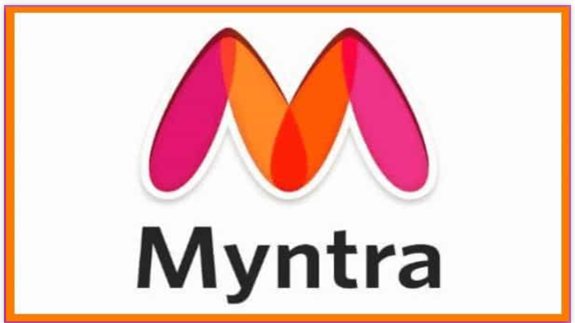

**Dashboard Page 2 : -**

**On the second page, I created some charts to represent the data.**

**Types of charts : -**

**Stacked column chart :-**

* **This chart shows the total sales of myntra products by brands,with the y-axis representing the sales value and the x-axis representing the brand name.**
* **The stacked column chart helps users visualize how each brand contributes to the total sales.**

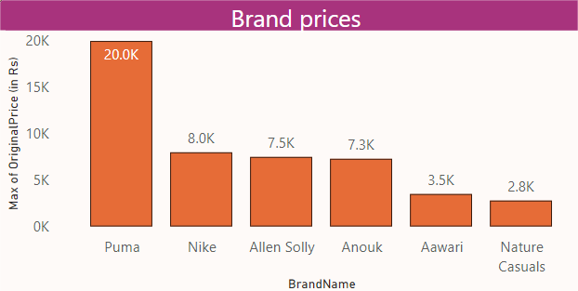

**Funnel Chart :-**

* **This chart displays the number of products sold by category(e.g., top,bottoms,dresses) at different price point(discounted or original).**
* **The funnel shape helps users visualize the progression of products from high-priced to low-priced categories.**

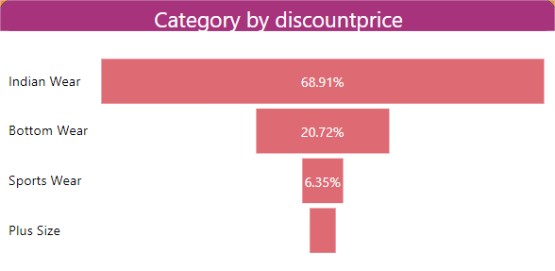

**Table :-**

* **This table provides a detailed breakdown of product sizes available for each category (e.g.,tops,**
* **bottoms,dresses).**
* **Users can filter the table by category to analyze the product sizes for each specific category.**

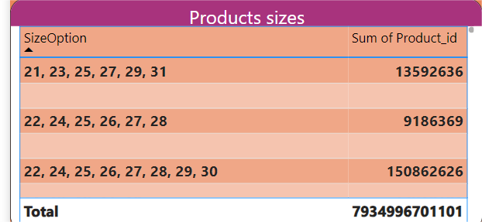

**Doughnut Chart :-**

* **This chart displays the percentage of products sold to each gender (Female or male).**
* **The doughnut shape helps users visualize the distribution of products by gender.**

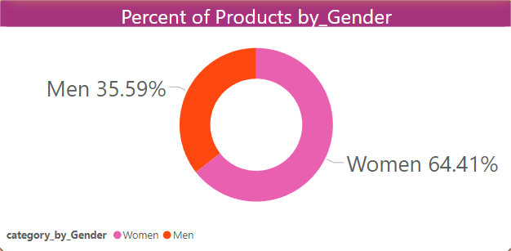

Tree Map :-

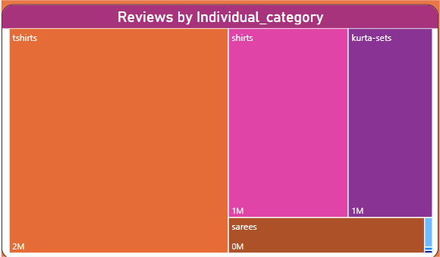

* **This chart displays a hierarchical representation of reviews for each category (e.g.,tops,bottoms,dresses).**
* **Users can drill down into specific categories to analyze reviews and rating.**

**Stacked Bar Chart :-**

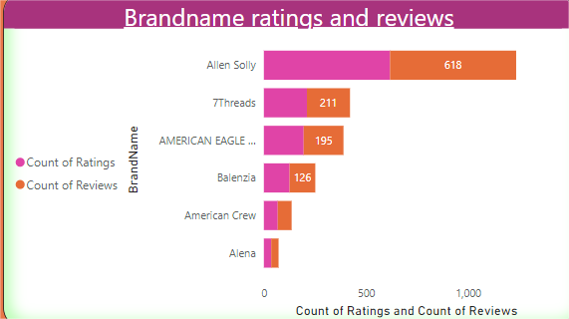

* **This chart shows the average rating and raviews for each brand, with the y-axis representing the rating & reviews and the x-axis representing the brand names.**
* **The stacked bar chart helps users visualize how each brand performs in terms of rating and reviews.**

**Area Chart : -**

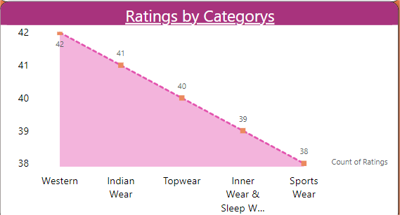

* **This chart displays the average ratings for each category(e.g.,tops,bottoms,dresses)**
* **The area chart helps users visualize how ratings vary across different categories.**

Waterfall Chart : -

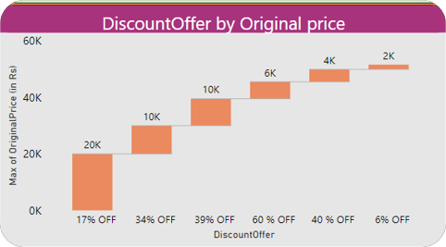

* **This chart shows the brackdown of discounts offered by original price for each product.**
* **This waterfall chart helps users visualize how discounts are applied to products.**

Ribbon Chart :-

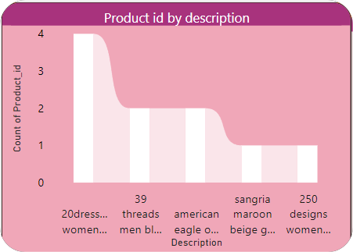

* This chart will displays a ribbion-like representation of product descripition and IDs.
* Users can filter the chart by product description to analyze specific products.

Cards : -

In this dashboard, I created two cards.

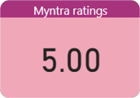1.Myntra Ratings Card :

* This card provides a summary of myntra’s

overall ratings and raviews .

**2.Myntra Reviews Card :**

* 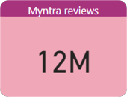**This card provides a summary of myntra’s reviews and ratings by category.**

Slicers : -

In this dashboard, I created two slicers. One is a brand name slicer on Page 1. The second slicer is for ratings on Page

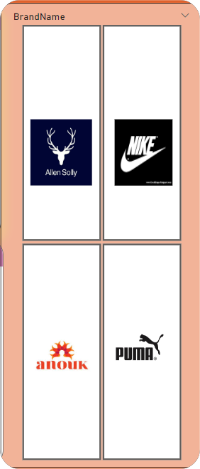1.Brand Slicer :

* When i select a brand, the entire page will be highlighted that brand.

* This slicer allows users to fliter charts by brand name.

2.Ratings Slicer : -

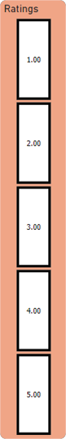 This slicer includes five rating numbers.

When i click on any rating number, it shows the entire

page of products with that rating.

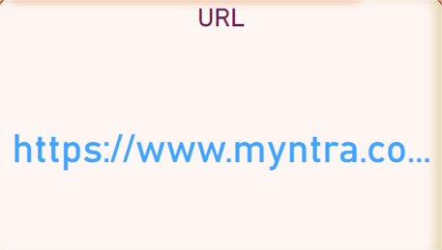Myntra URL Link : -

This link provides a direct

path to myntra’s website.

Myntra App Image : -

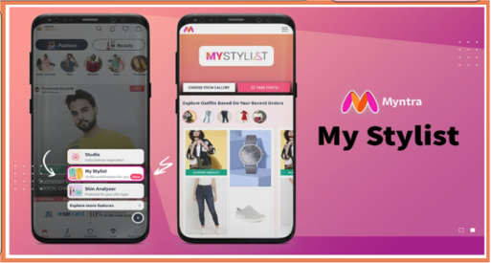

This image is displayed in the open interface and serves as a visual

representation of myntra’s brand.

Detailed Matter : -

The project report provides a comprehensive analysis of myntra’s fashion products, including:

* Sales date:

The stacked column chart shows total sales by brand, while the

funnel chart displays sales by category at different price point.

* Product size analysis : -

The table provides a detailed breakdown of product sizes available for each category.

* Gender analysis : -

The doughnut chart shows the percentage of products sold to each geder.

* Review analysis : -

The tree map displays reviews for each category, while stacked bar chart shows ratings and raviews for each brand.

* Category analysis : -

The area chart will displays average ratings for each category.

* Discount analysis : -

The waterfall chart shows the breakdown of discounts offered by original price for each product.

* Product description analysis : -

The ribbon chart displays a ribbon -like representation of products descriptions and IDs

The project report provides valuable insights into myntra’s fashion products, helping users analyze sales data ,product sizes,gender distribution, reviews, ratings, discounts, and product descriptions.

Dashboard



